Yiyun (Leo) Yao

Professor Brian Culver

ACC-UF 102 037

April 10th, 2022

The Embodiment of Gothic Equilibrium throughout Various Mediums

and Cultures of Arts from the Middle Ages

Gothic arts are one of the most well-known and widely collected classifications of arts that flourished in Europe during the Middle Ages, also known as the Medieval Period. Although Gothic arts involve various mediums - from the more literal arts such as literature and music to the more visual arts such as painting, sculptures, and architecture, they all share the same core value: the Gothic equilibrium.

The Gothic equilibrium is a concept proposed by British historian Derek Pearsall in his 2001 book *Gothic Europe*. According to him, Gothic is an equilibrium of contrary forces. It is a peaceful but elastic moment of harmony and restlessness among different elements of style. It appears to be on an imminent collapse but never truly falls.

Under this perfect tension, the Gothic equilibrium keeps a balance of naturalistic and expressionist approaches to visual representation. That is, the Gothic equilibrium can also be understood as the relationship between the spiritual and the human. The Gothic equilibrium can be simultaneously seen as the spiritualization of the human and the humanization of the spiritual.[1] Both coexist with each other. If the human loses the mediation of the divine or the divine surpasses the human, the Gothic equilibrium collapses and Gothic arts loses its soul segment of beauty.

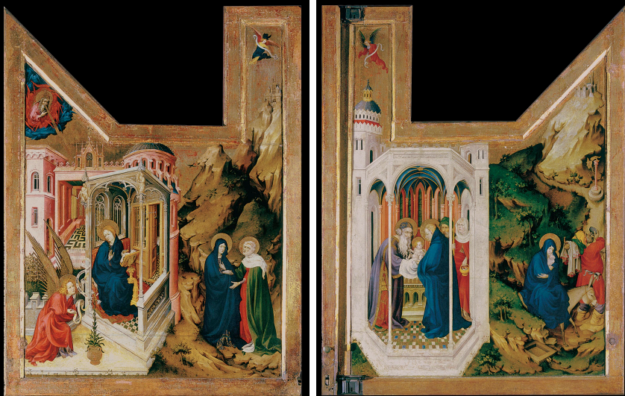

For example, this painting above is *Annunciation and Visitation*, a Gothic visual art by a Flemish artist, Melchior Broederlam, painted from around 1393 to 1399. Broederlam’s painting depicts the famous annunciation story, where the archangel Gabriel approaches the Virgin Mary, announcing her prospective birth of Jesus, the son of God. The Virgin Mary, in turn, stares at Gabriel, appearing to be patiently listening to him and contemplating herself.

The painting is a two-dimensional one painted on a wood panel. Broederlam uses various artistic techniques to help illustrate his painting as a more realistic projection of the annunciation in the audience’s mind. The hollow area to the top of the painting is an intriguing design of composition that not only makes the two-dimensional painting seem more three-dimensional but also makes up the spiritual component of the Gothic equilibrium.

The contour lines of the compartment where the Virgin Mary rests on are rigid and clear, while the implied and plane lines of the lily on the ground, the draperies of both the Virgin Mary and archangel Gabriel, and the buildings behind them are vague and less definitive. The emphasis of the painting is on the left and bottom half of the painting, which is shown by the contrasting use of colors: marble white in the foreground and yellowish gold in the background. All of them are contrary forces that exhibits the Gothic equilibrium, with the rigid and clear white representing the human and the vague yellowish gold representing the spiritual.

In Broederlam’s painting, the pigments are mixed with linseed oil.[2] Such use allows the oil to dry slowly. Therefore, the painter is able to make more changes before the paint is fully aired and attached to the panel’s surface. Those changes are fine, slight details painted with the tip of a brush. Multiple layers of such changes give the painting more depth and saturation. As the best painting medium for translucency and light reflection, Broederlam’s use of oil paint also improves the texture and mass of the painting. It makes a better quality of the painting’s surface, making it shinier and more illuminating. It also makes the real mass more real and the illusionistic space more illusionistic, rendering a more three-dimensional impression and perfectly displaying the Gothic equilibrium.

When people think of Gothic art, many may assume that Gothic art is a style that developed in the 12th century in Europe and lasted until around the 15th century. However, there have been long-lasting arguments over the longevity of Gothic art. Is there continuity between the arts before and after 1400? Are the arts after 1400 still considered Gothic art? On one hand, some argue that 1400 is the turning point that marked the undoubted end of the Medieval Gothic Arts. On the other hand, some argue that the Medieval Gothic Arts lasted as late as the end of the 16th century in some parts of Europe. They name the arts from the time period after 1400 “Late Gothic Medieval Arts”.

The Cloisters, Metropolitan Museum of art indeed contains a large volume of art collections from the Late Gothic Period. This painting below is located in Gallery 17 in the “Unicorn Tapestries Room”. It is originally from Southern Netherlands, though the artist who creates it remains unknown. The painting is called *The Unicorn Is Found*, also known as *The Unicorn Purifies Water*, created approximately from 1495 to 1505.

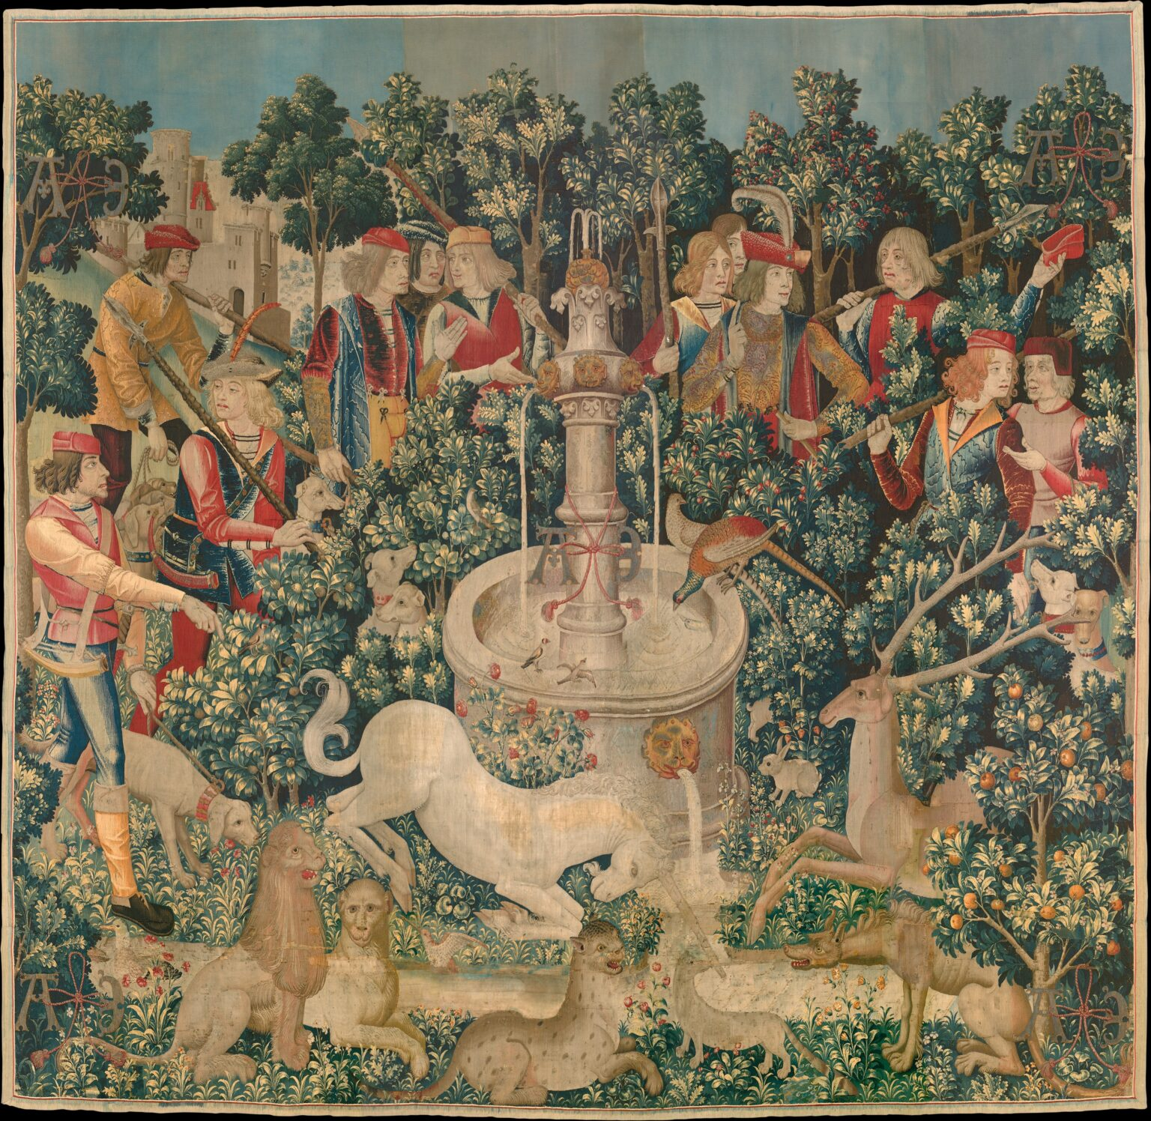

This whole gallery of “Unicorn Tapestries” depicts the world of the unicorn, a mythic animal that inhabits a world that ensembles our real world, secular and religious, human and spiritual. In this particular painting, the unicorn kneels before a tall, thin white fountain that has a pair of pheasants and a pair of goldfinches perched on its edge. The unicorn’s true magic lies in its horn’s ability to detect the presence of poison and purify the water poisoned by serpents. As the elegant beast kneels at the edge of a stream, animals and hunters gather to witness the extraordinary moment. For this moment, they seem at peace with one another, as if astonished by this spell and if only until the spell breaks. Their chasing of this mythical unicorn echoes with the faith in God as one of the most important elements that frequently appear in most Gothic arts.

The name of the gallery “tapestries” already suggests that the painting is one dyed on a wool textile. Although the form of this painting is different from Melchior Broederlam’s *Annunciation and Visitation* from a century earlier, they share a large number of similarities, in their respective use of formal elements to establish the Gothic equilibrium.

In this painting, the focus is on the unicorn and the fountain, located in the lower center of the image. Though slightly different from Broederlam’s *Annunciation and Visitation*, the style of composition and space is similar. Both paintings use a marble white color to illuminate the emphasis, adding depth and saturation, putting it in the foreground, and sinking the rest of the painting into the background. This painting also widely applies the green color on flowers and leaves, rendering subtle details that not only make the painting look more vivid and realistic but also make better contrast with the emphasis at the center. In the background, the flora, the fauna, and the hunters represent the humanizing aspect of the painting while the unicorn and the fountain represent the spiritualizing aspect, again forming the Gothic equilibrium.

What is different from Broederlam’s *Annunciation and Visitation* is the presence of symmetry in this painting. The fauna, the flora, and the hunters are all symmetric to each other, left to right and right to left, implying two contrary forces. Altogether, they form a circle that encloses the fountain and the unicorn. This real space creates an illusionistic mass in the audience. It helps the audience to make a connection to the depiction in the painting and sense the surrounding forces toward the center which form the Gothic equilibrium.

As shown, the Gothic equilibrium exists in all Gothic visual arts, whether it is from an earlier time period or the Late Gothic Period. However, as unlikely as it may seem, the Gothic equilibrium may also exist, more or less, in arts from other cultures and time periods such as the Islamic arts!

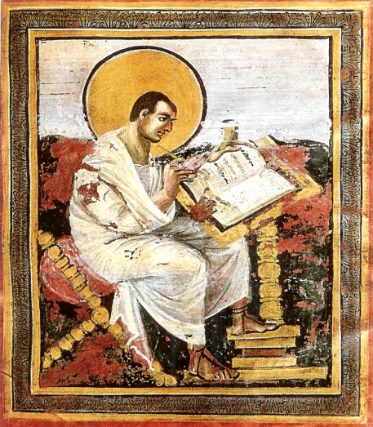

For example, this painting above is *Saint Matthew*, Folio 15 Recto of the Coronation Gospels, or Gospel Book of Charlemagne, from Aachen, Germany, created around 800 to 810. It is a two-dimensional Islamic visual art from the Carolingian era, a time period named after Charlemagne, also known as King Charles the Great, emperor of Rome. Art traditions at that time have evolved from Ancient Roman, Byzantine, and Persian arts, keeping mostly Roman.

This painting depicts Saint Matthew, who is the composer of the Gospel of Matthew, wearing a Roman toga, sandals, and a typical Roman orator hairstyle. The seated pose of Saint Matthew also resembles that of Ancient Roman portraits of writers, such as this one from a mural painting of the poet Menander. Even the modeling of color on Saint Matthew’s face and neck, the highlights on his right knee, and shading of the drapery falling between his knees suggests a deliberate attempt to emulate these techniques used in Ancient Roman painting. Less obvious at first glance is that the border of the Saint Matthew illustration is decorated with acanthus leaves that resemble those in Corinthian capitals from many Ancient Roman temples.[3]

But they all represent the Gothic equilibrium in some ways! Similar to both Melchior Broederlam’s *Annunciation and Visitation* and *The Unicorn Is Found*, the highlighting color on Saint Matthew’s face and neck shifts the center of focus to his face, making an illuminating effect and moving him to the foreground. It makes the two-dimensional painting more three-dimentional and creates a sharp contrast with the other three color segments in the background.

Similar to *The Unicorn Is Found*, *Saint Matthew* is also approximately symmetrical. Together with the decoration of leaves at the border of the painting, its symmetry renders the painting a more illusionistic space and mass, creating more pressure toward the center of focus. The painting as a whole creates an image of Saint Matthew, located at the center, dispersing the surrounding dark elements as he writes the Gospel. The Gothic equilibrium appears once again as the contrary forces keep a balance between naturalism and expressionism.

Nevertheless, the Gothic equilibrium not only exists in visual arts but also exists in other mediums of arts. For example, it exists in literature and music, including verse and lyrical poems. *Can Vei la Lauzeta Mover* is a Canso lyric poem written by Bernart de Ventadorn, the most famous 12th-century troubadour.

Throughout history, only art pieces of those who have the power are preserved, while others mostly vanish. As a result, in the Medieval Period, the spiritual music of the church has been much better preserved than the secular music. The troubadours songs are the first preserved secular music. And *Can Vei la Lauzeta Mover* is one of the oldest and best-known troubadour songs.

The medium of *Can Vei la Lauzeta* *Mover* is a verse. The mode is lyric. The texture is polyphonic. The form is strophic and syllabic, meaning each stanza is set to the same melody. Like the symmetry in *The Unicorn Is Found*, the paralleled structure of stanzas and the symmetrical structure of the melody both help create tension and power in the emotions that the poem is trying to convey. The Gothic equilibrium manifests among the contrary forces.

The first-person narrative of the song helps enhance the empathizing effect of the song. The audience feels as if someone is actually speaking the lyrics to them in front of them. This is a naturalistic approach, aiming to make the most humanly natural performance. On the contrary, the softened dynamic, the smooth tone color, the high pitch, and the slow rhythm make up a peaceful, consonant harmony that spiritually conveys the despair of the protagonist. This is a practice of expressionism. The repetition of the melodies throughout the song as well as the resolution harmony that echoes with the haunting, tragic ending is also expressionistic.

Given that the song is secular music, the expressionistic approach spiritualizes the human, or the secular, and the naturalistic approach humanizes the spiritual. They counter each other and blend together to create the Gothic equilibrium. Under this perfect balance, the audience is able to feel the desperate, complicated emotion that the poem is trying to convey.

Throughout history, the Gothic equilibrium generally exists in all different mediums of Gothic arts. However, it may additionally exist, more or less, in some arts from another culture or another time period such as the early Islamic arts. The Gothic equilibrium does not only fit into Gothic arts since Gothic arts inherit from earlier ancient art styles such as the Romans and the Persians.

1. *Gothic as Period Style*
2. *Global Art of the First Half of the Second Millennium CE, Part III - The 14th Century* pp. 9
3. *Global Art of the Second Half of the First Millennium CE* pp. 12